Government of Maharashtra

Government College of Arts & Science, Aurangabad (M.S)
(Established in 1923)
(Kile Ark, Near Subhedari Guest House, Aurangabad)
Email ID: gasca1923@gmail.com | Phone/Fax: 0240-2331476 | Website: www.gasca.ac.in
INSTITUTIONAL BEST PRACTICES
Practice No.1
1. Title of the practice: Music For all
2. Objectives of the Practice
1.To create cultural atmosphere in the society as well as to preserve heritage of Indian classical music.
2. To promote Indian classical music and to establish awareness of Indian classical Music, for our society.
3.To entertain and make the people stress free through the music and to create peaceful life for everyone
3. The Context:
- Preservation of classical Music is preservation of our cultural heritage. Preservation through Music festivals is an interaction of young population with classical music. It is a medium to quench the cultural thrust of the society as well as students of GASCA.
- At the same time music works like a medicine in pain and stress. That’s why entertaining to the society is also an important task. It is a medium to connect with the society. Music Department students performs songs for cancer patients also
- Students performs for old age people for entertainment. This is a kind of social responsibility.

4. The Practice:
- Gandharv Music Festival: Department of Music organizes Gandharv Music festival since 2017. College invites legendary artists to perform their art in this festival. Performance include vocal music and Instrumental music. Our College is one of the oldest institutions for higher education in Marathwada region of Maharashtra state. Department of Music is an oldest department in the region. Very few colleges have music as an optional subject at U.G. and P.G. level. Most of the students admitting here are from rural area and underprivileged group. Many of them possesses good singing Qualities. This festival has brought out an exposure for performing arts.
- It gives great opportunity to experience performance of stalwarts in music for those students who are artists of tomorrow. Performance by vocalist and performance on instruments are two parts of this festival. Dept of Music attempts to introduce different artists for not only students but also for citizens of Aurangabad. Music lovers use to attend and enjoy festival. Finance for this festival is through sponsors in the society like United Sigma Hospital, Aurangabad. State Bank of India, Vijay Gears Industries, Aurangabad.
- Performance of Patriotic songs Ek salaam Desh Ke Naam
Students from department of Music performs patriotic songs at different places in Aurangabad city. A group of 8 to 9 students from department of music performs patriotic songs at different places in Aurangabad City.
- Social Responsibility
Students performed old songs at ‘Matoshri Old age home’ for old people. Students gave a treat of Old Melodious Songs to the old people who are living in the old age home without their own family.
Students not only entertained them but also helped to reduce their pains also.Students performed at Cancer Hospital for Cancer patients in Aurangabad City. This Programme is titled as ‘Phunkar’. Phunkar is a word in Marathi Language used for expressions like encouraging, reassuring, soothing.
- Creating opportunities and platform for stage performance
Music department organizes Bharatratna Lata Mangeshkar State level competition every year. There is good response to this competition from Maharashtra.
5. Evidence of Success
- This activity has created benchmark for other institutions. Aurangabad city is a part of Marathwada region. There are few cultural festivals. That’s why Gandharv Music festival arranged by educational institution is unique in itself.
- All students of our college as well as disciples of classical music attend Music festival. Many artists in music field appreciated this festival.
- This event gives an opportunity to our students to listen performance of stalwarts in this field.
- Interests in classical music has generated among students. Various activities regarding musical performance boosted the confidence of students.
- Many students have created their own cultural group. Musical performance on various platforms has created financial opportunities for earning also.
6. Problems Encountered and Resources required
- There is need of financial support for organization of Gandharv Music festival at college as well as at regional level.
- There is need for separate transportation facility to carry instruments and other essentials.

BEST PRACTICE I-MUSIC FOR ALL
LEGENDARY ARTISTS WHO PERFORMED IN GANDHARV MUASIC FESTIVAL
Sr. No. | Name of the Artist who performed in the festival | Date and Year
1. | VidushiDevaki Pandit (vocalist) | 22-2-2017
2. | Pandit Govind Bhilare(PakhvajArtist) | 22-2-2017
3. | Dr. Ashwini Bhide Deshpande (vocalist) | 4-12-2017
4. | Pandit Ramdas Palsule(Tabla Artist) | 4-12-2017
5 | Pandit Kalyan Apar( ShahnaiVadan) | 4-12-2017
6 | VidushiAarti Ankalikar(vocalist) | 1-12-2018
7. | Pandit Sunil Kulkarni (vocalist) | 1-12-2018
8. | Pandit Sunil Avchat(Flute Artist) | 1-12-2018
9 | Pandit Shashank Maktedar(Vocalist) | 31-1-2019
10 | Pandit RonuMuzumdar(Flute Artist) | 31-1-2019
11 | Pandit Arvindkumar Azad (Tabla Artist) | 31-1-2019

ACTIVITIES UNDER BEST PRACTICE: MUSIC FOR ALL

GLIMPSES OF GANDHARV MUSIC FESTIVAL
PANDIT RONU MUJUMDAR
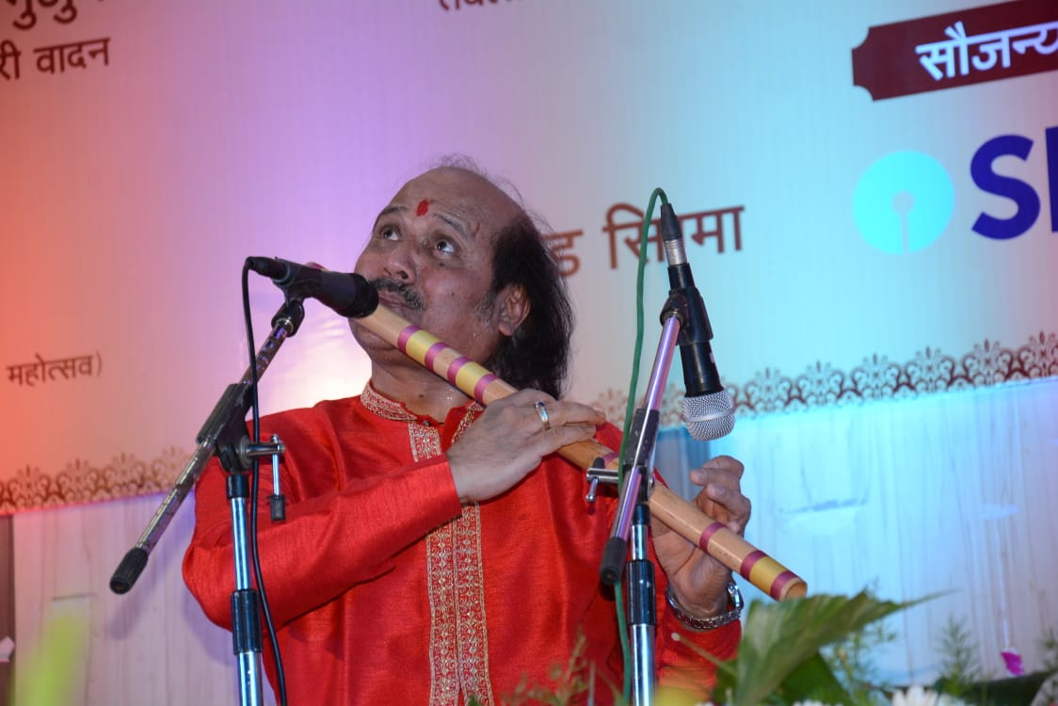
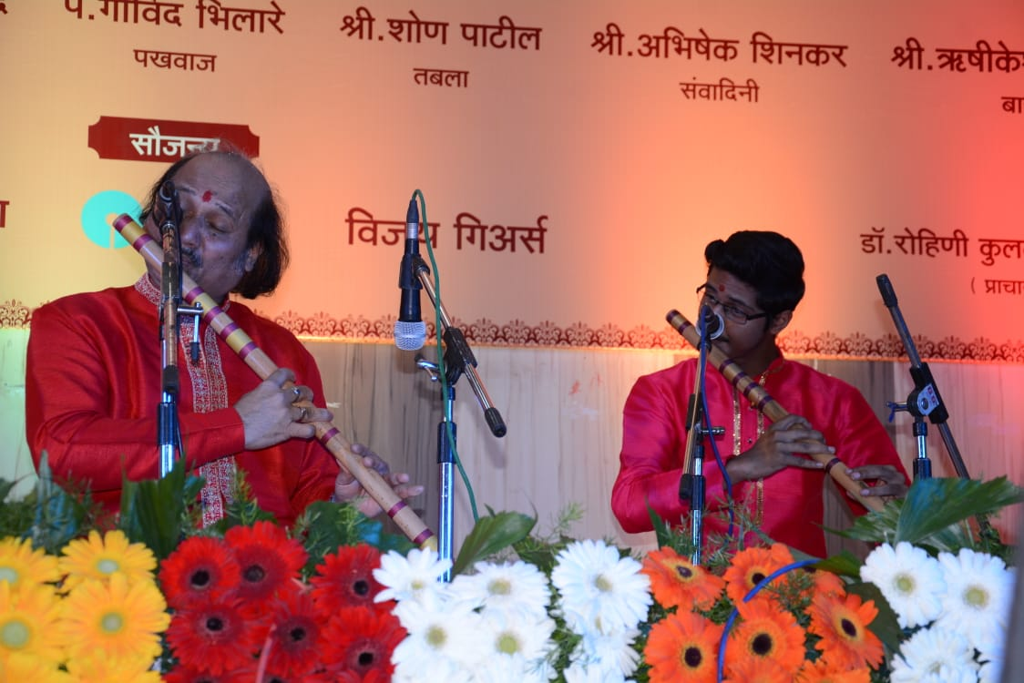
PANDIT SHAHSANK MAKTEDAR
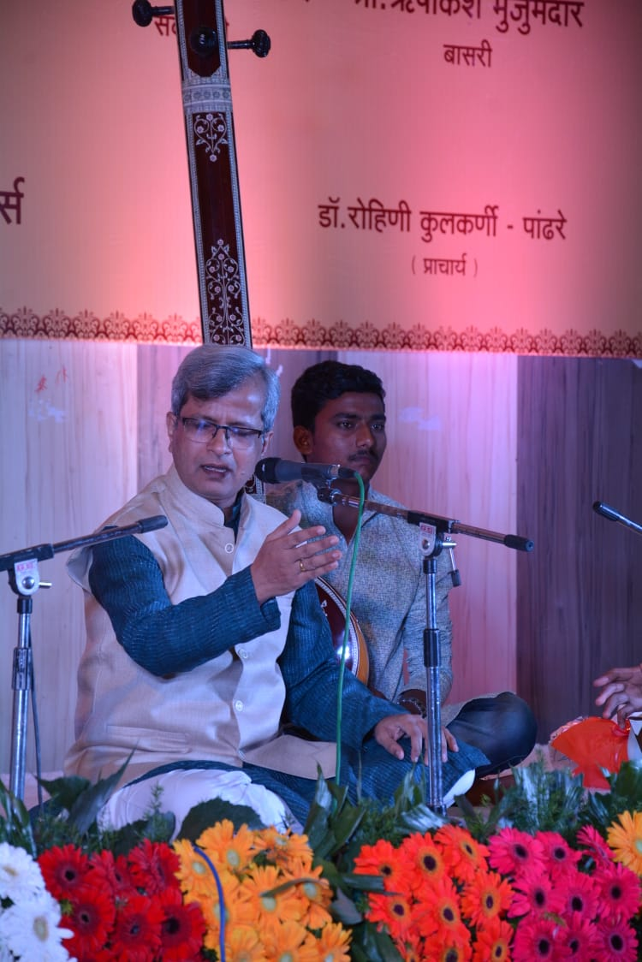
PANDIT SUNIL KULKARNI
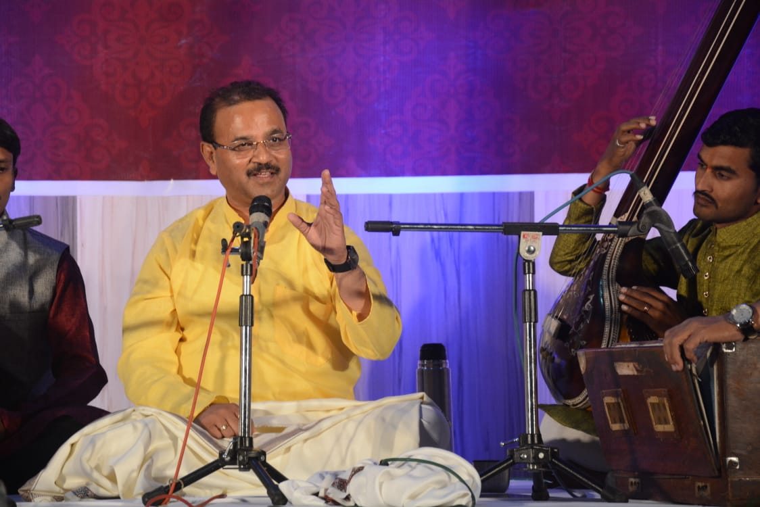

PANDIT SUNIL AVCHAT
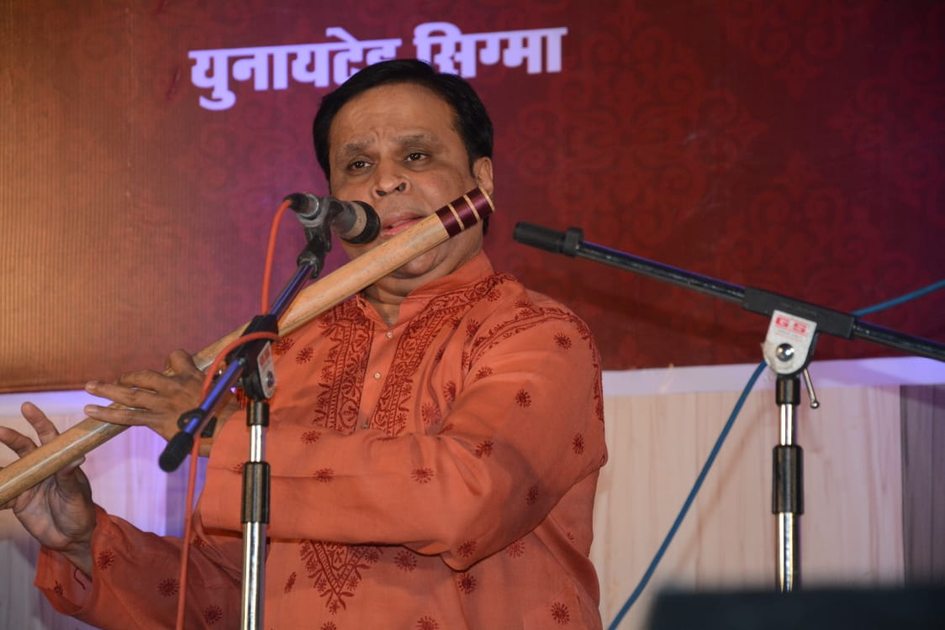
VIDUSHI ARTI ANKALIKAR-TIKEKAR
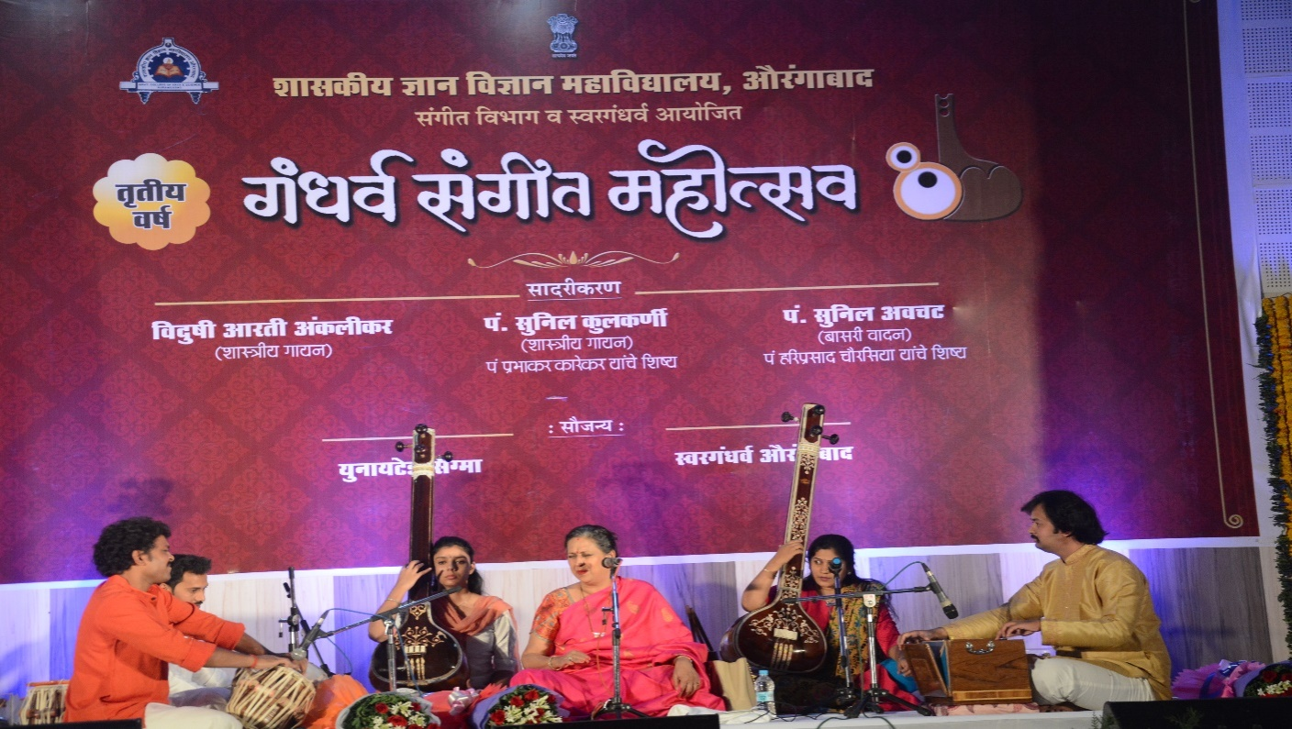

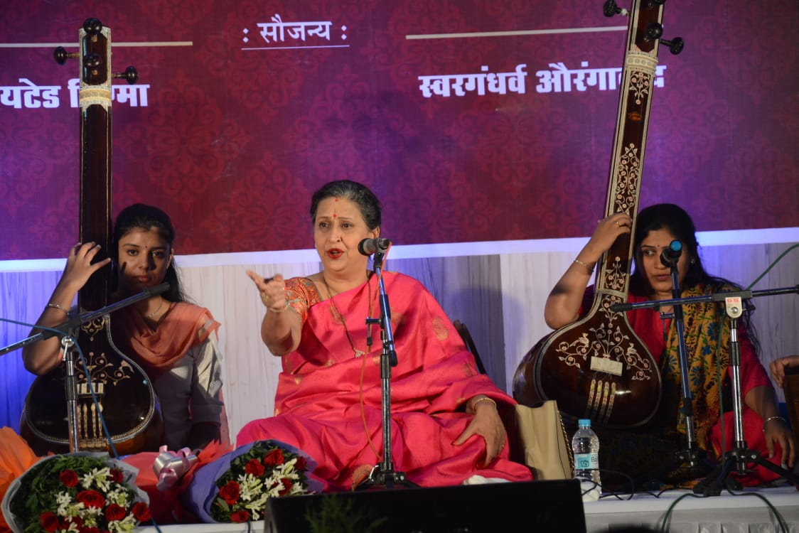

AUDIENCE FOR FESTIVAL
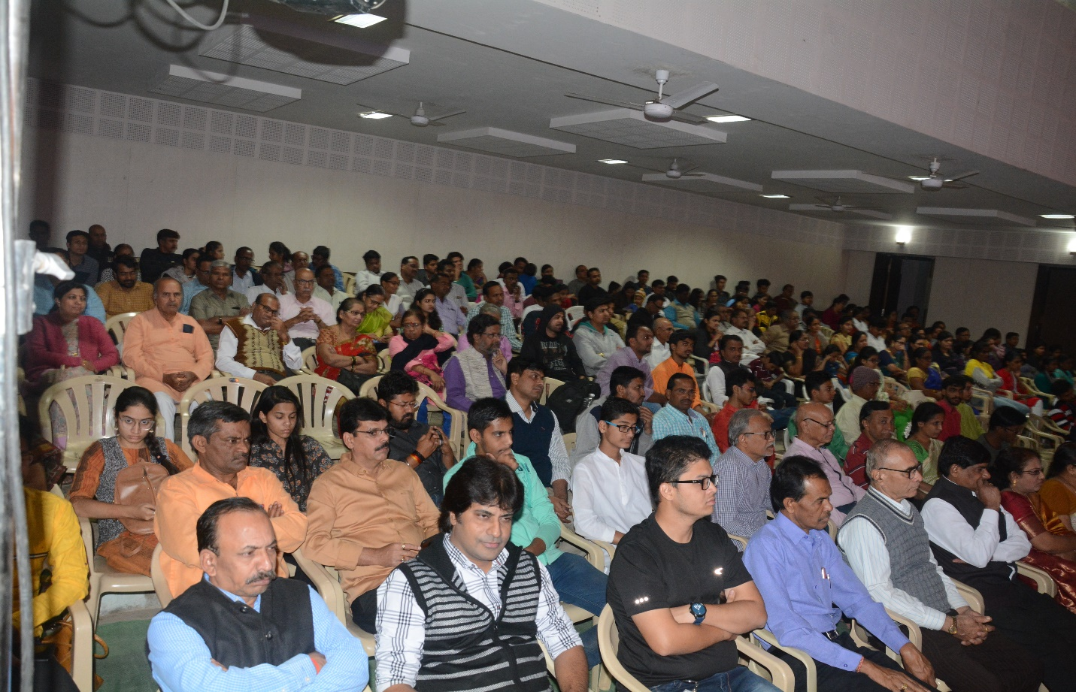
PERFORMING PATRIOTIC SONGS AT PROZONE MALL
EK SALAM DESH KE NAAM
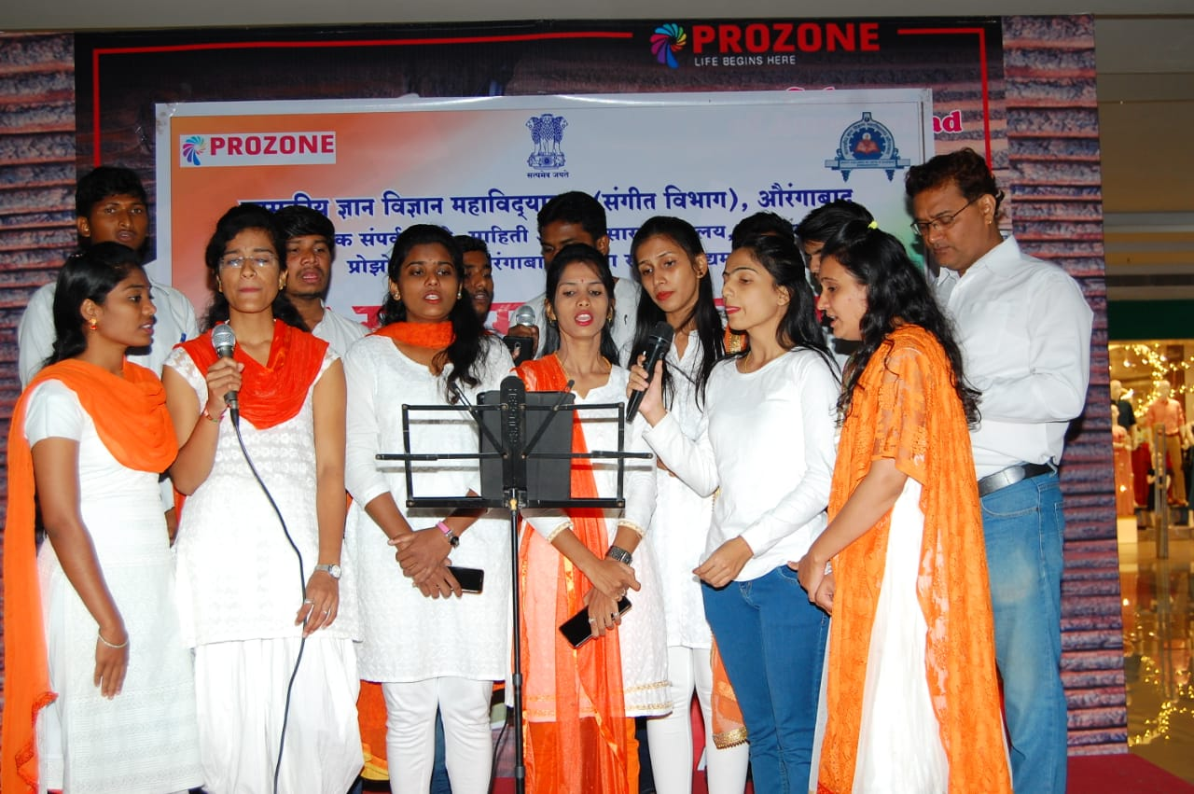

PERFORMING PATRIOTIC SONGS AT BHAGWANBABA
BALIKA ASHRAM

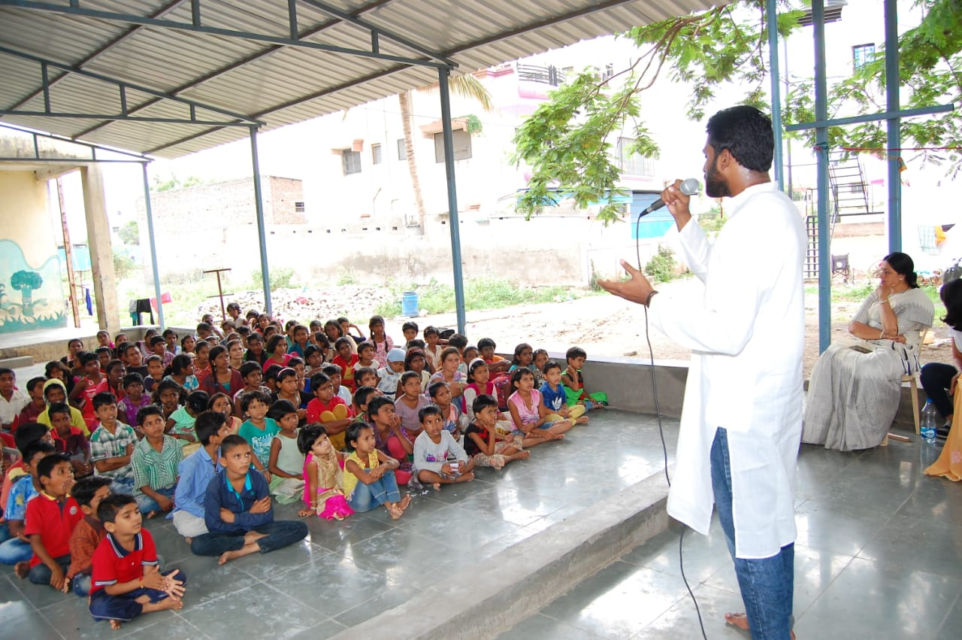
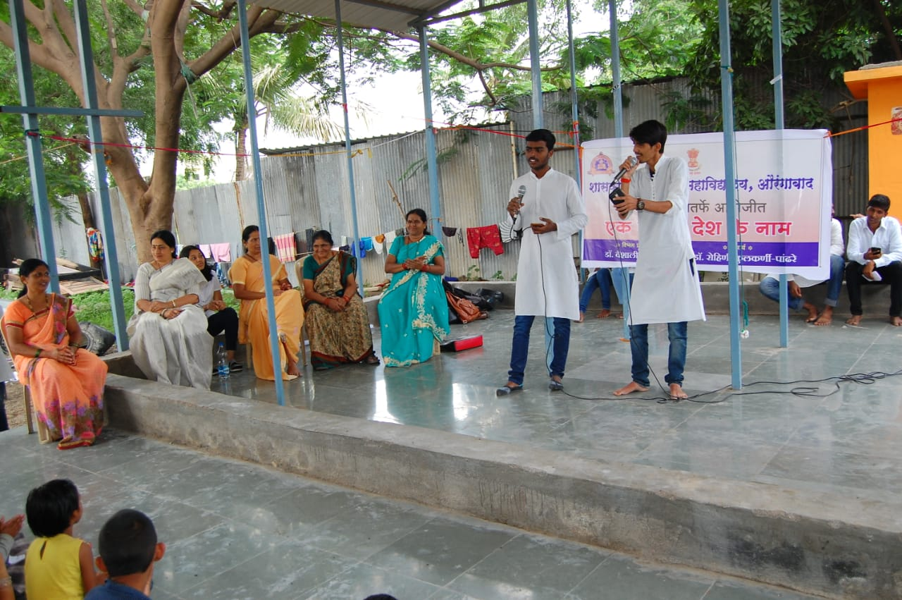
STUDENTS PERFORMING AT SOUTH CENTRAL RAILWAY OFFICE ON 14-8-2022.
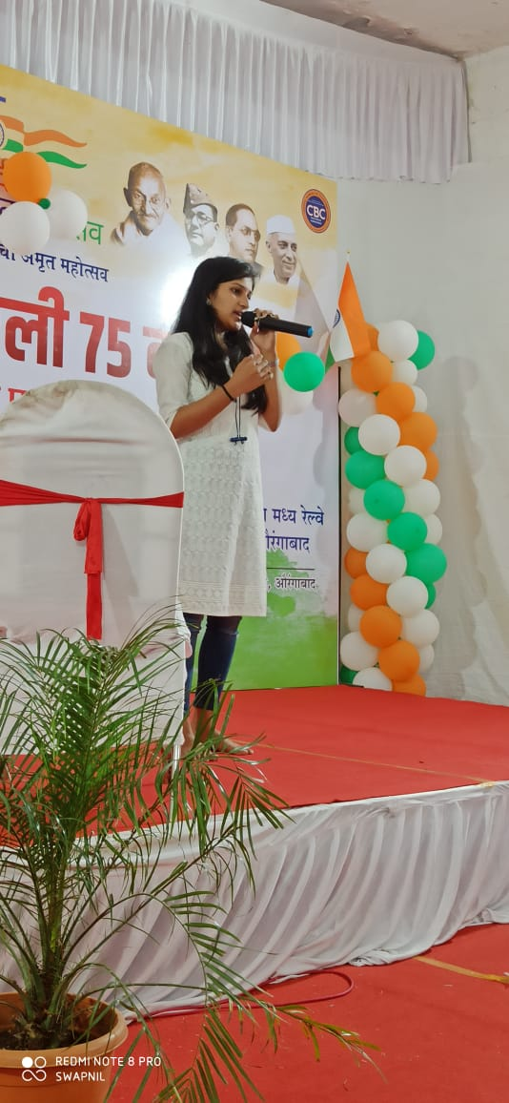

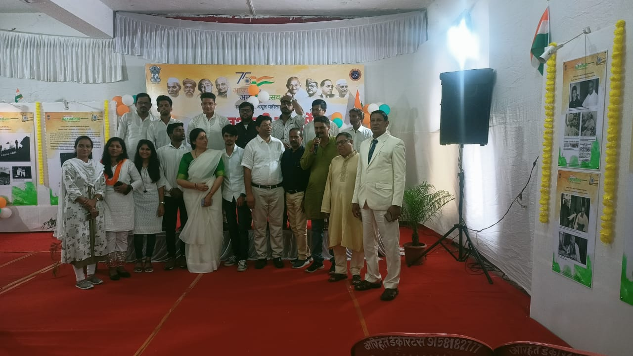
BHARAT RATNA LATA MANGESHKAR STATE LEVEL SINGING COMPETITION
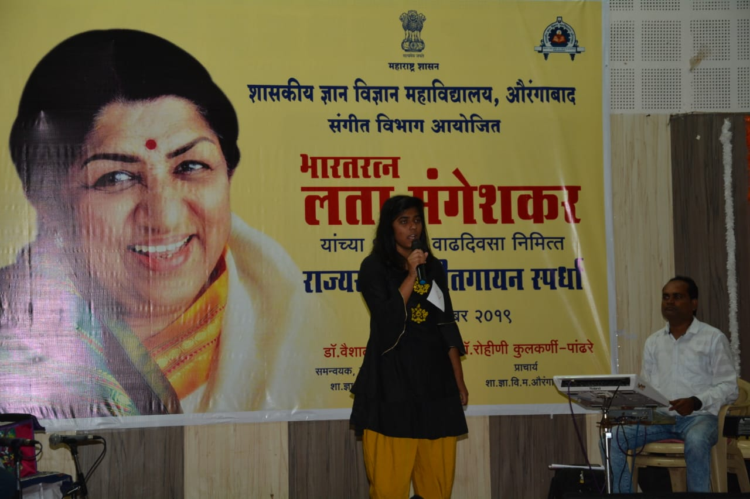
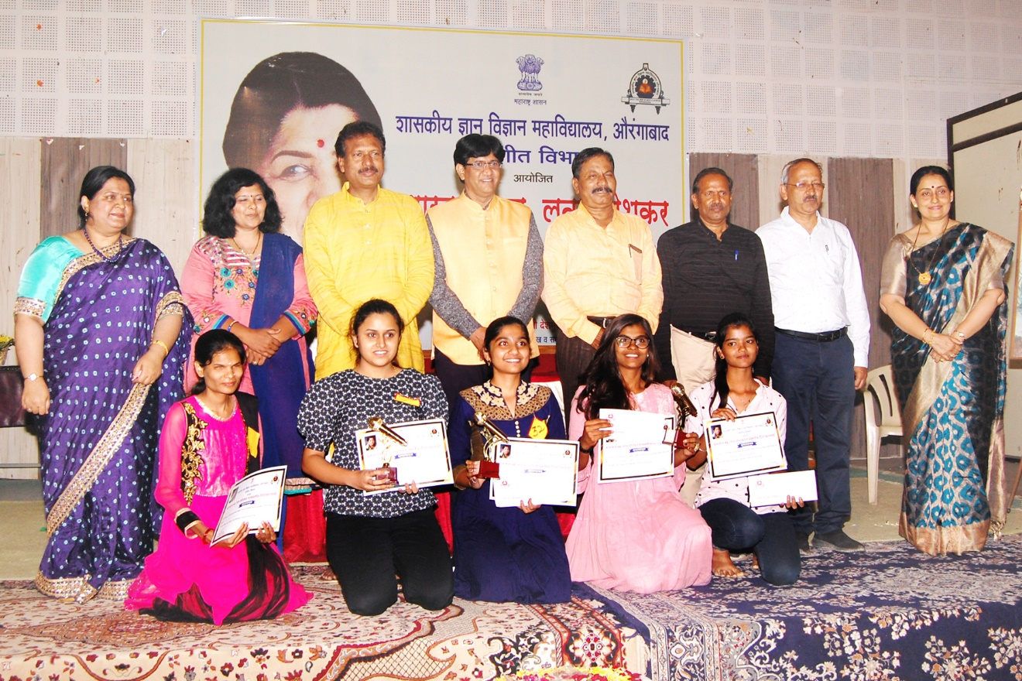

PHUNKAR ACTIVITY
STUDENTS FROM MUSIC DEPARTMENT PERFORMING AT CANCER HOSPITAL
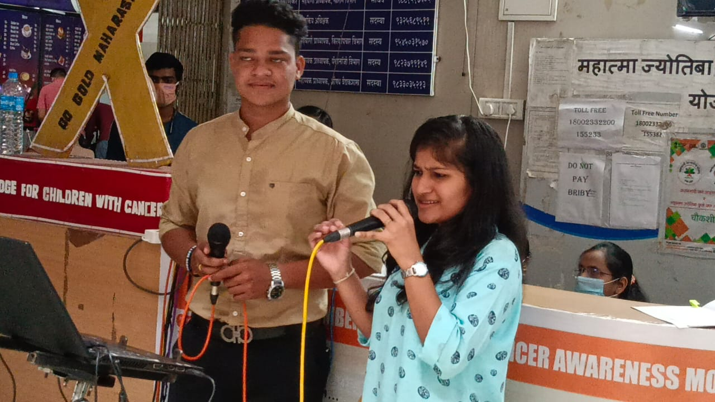
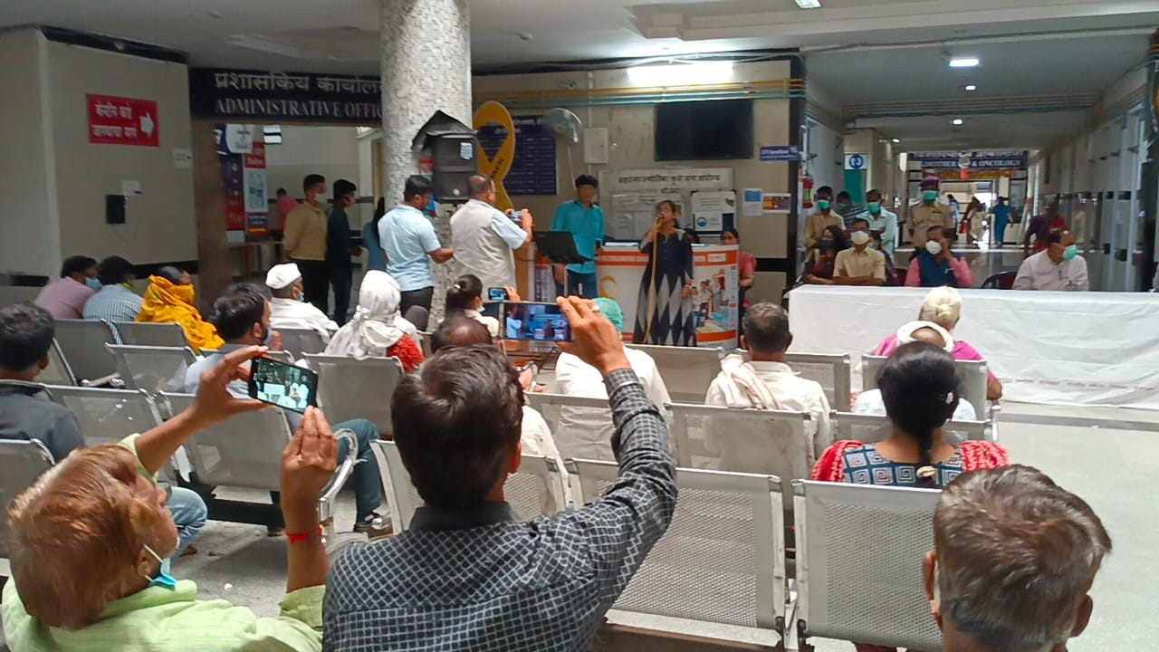

MUSICAL PERFORMANCE IN MATOSHRI OLD AGE HOME
MELODIOUS SONGS IN MEMORIES
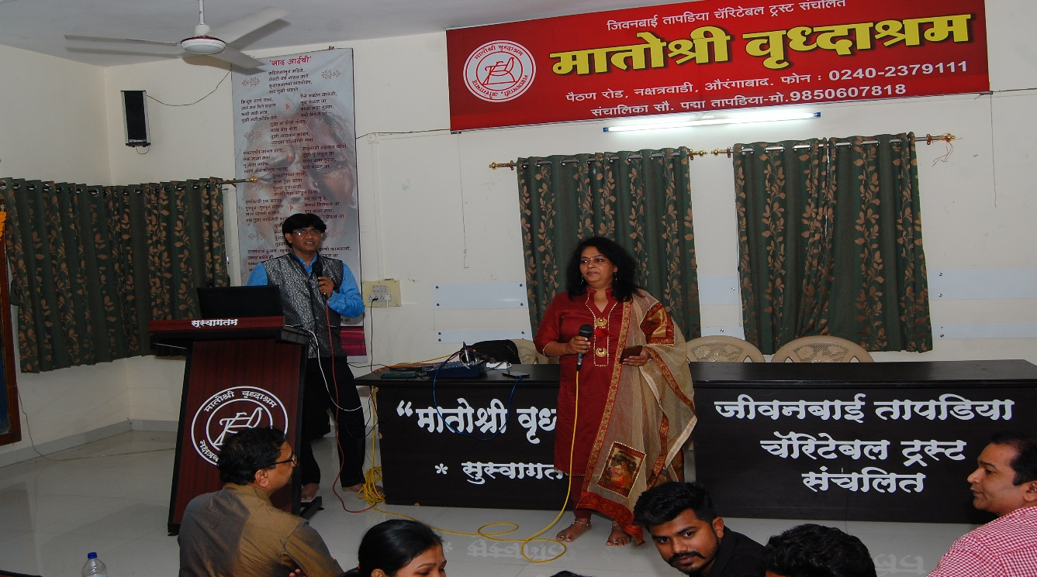
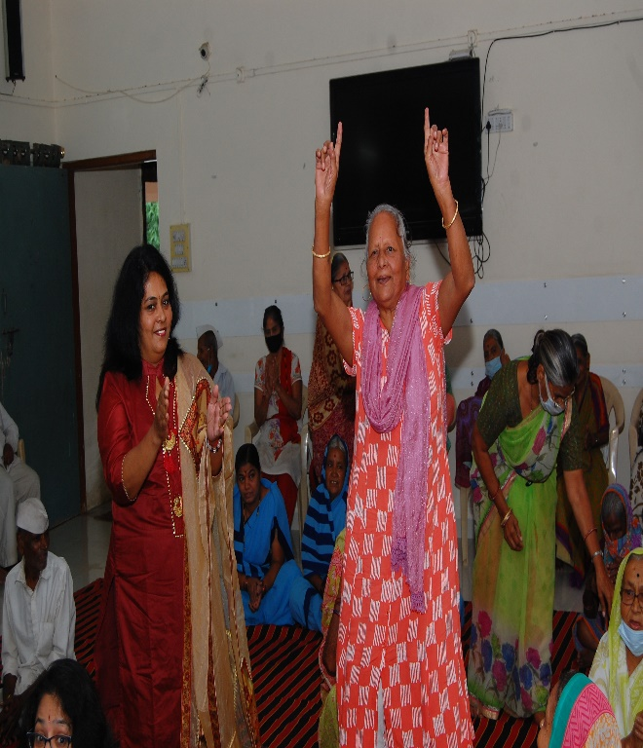

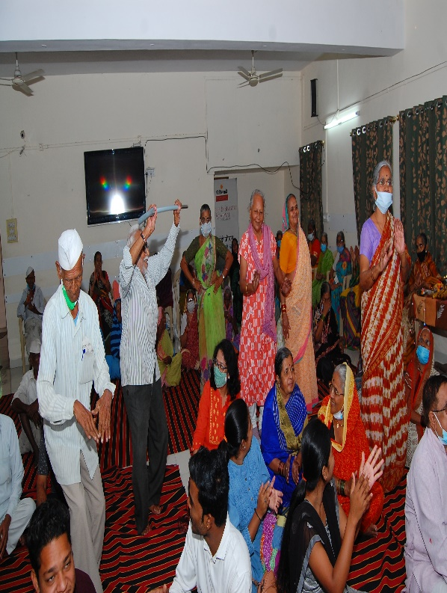
GANDHARV MUSIC FESTIVAL IN NEWS
